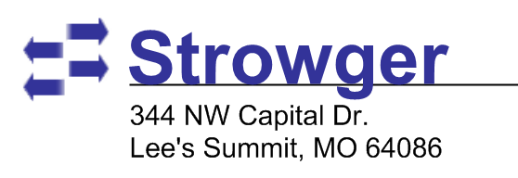
Evaluation Request Form
I hereby request Strowger, Inc. to loan the equipment itemized below for a 30 day evaluation period. The evaluation period may be extended at Strowger’s option. At the end of the evaluation period I will either return or pay for these units. Late payments are assessed a late fee of 2% of the account balance. A 5% equipment rental fee is assessed each month if evaluation is not renewed. Products returned with missing components will be invoiced for a pro-rated refurbishing fee. Credit card will be authorized. Card will not be charged so long as the product is returned as agreed. Please email this form to opns@strowger.com or fax to (646)607-1052.

Name:
Company name:
Phone: |  | Fax: |  |  | E-mail:
Registered company address:
City: |  |  |  | State/Province/Region: |  | ZIP/Postal:
Credit Card Info
Name:
Number: |  |  |  |  | Expiration: |  | CCV:
Billing Address:
Product Request
Quantity | Part Number |  | Description |  |  |  | Price
Equipment Return Procedure
- Visit http://rma.strowger.com and fill out the RMA Request form.
- Once a technician has reviewed your request you will be assigned an RMA number and receive shipping instructions via the email address you provide.
- Once the equipment is received and inspected the evaluation process is complete.
Signature
Title:

Date:

